NETWORK FUNDAMENTALS AND BUILDING NETWORKS

Assignment day 6

TASK1: Create a table listing the main functions and typical ports used by switches, routers, hubs, firewalls, and access points in a home WiFi setup.
Device | Main Function | Typical Ports
Switch | Connects multiple devices in a LAN and transfers data between them. | Ethernet Ports (LAN), Power Port
Router | Connects the local network to the Internet and assigns IP addresses. | WAN Port, LAN Ports, Power Port
Hub | Connects devices and sends data to all connected devices. | Ethernet Ports, Power Port
Firewall | Protects the network by blocking unauthorized access and harmful traffic. | Ethernet Ports, Console Port (in some models), Power Port
Access Point (AP) | Provides wireless (Wi-Fi) connectivity to devices. | Ethernet Port, Power Port, Antennas

TASK2: Given images or diagrams of network devices, label each device and mark the ports (Ethernet, console, power, antenna) for at least three devices.
ROUTER:
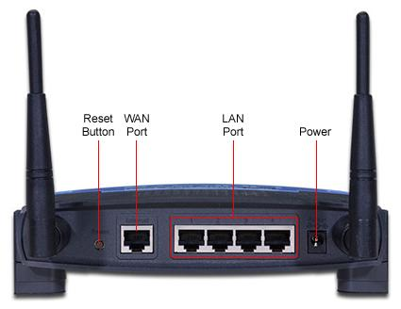
NETWORK SWITCH:
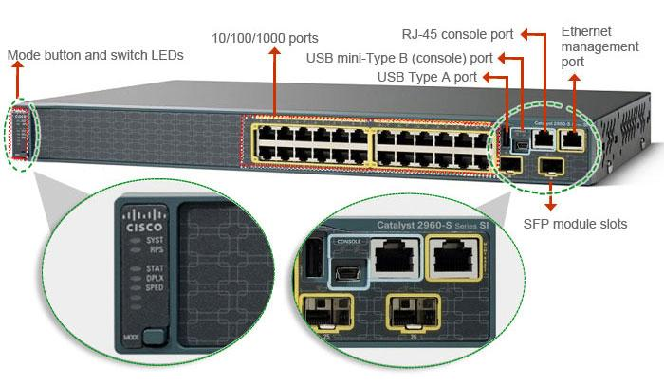

WIRELESS ACESS POINT:
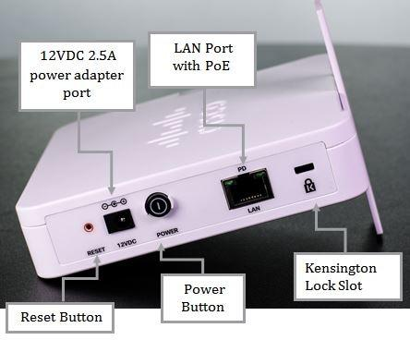

TASK3: Pick a popular app you use daily (like Instagram, Zomato, or Paytm) and describe in 3-4 lines how at least two different network devices (from switches, routers, firewalls, access points) play a role when you use that app.
I use Instagram every day to watch reels and upload photos.
When I open Instagram, my phone first connects to the Access Point (Wi-Fi Router), which provides the wireless internet connection.
The Router sends my request to the Internet and receives the data from Instagram's servers. If a Firewall is present, it checks the traffic and blocks any harmful or unauthorized connections before allowing the data to pass.

TASK4: Suppose your college WiFi is slow and sometimes disconnects. Based on the features of access points, switches, and routers, suggest one possible reason for the issue and how upgrading one device could help.<br><br><em><strong>Hint:</strong> Think about device capacity, coverage, and traffic handling.</em>

One possible reason for slow and disconnecting college Wi-Fi is that the Access Point is overloaded because too many students are connected at the same time. This can reduce speed and cause connection drops.
Upgrading to a higher-capacity Access Point or installing additional access points can improve Wi-Fi coverage, reduce network congestion, and provide faster and more stable internet access.

